Patient Name: __________________________ Date of Birth: _____________________

Cell Phone: ____________________________ Home Phone: _____________________

Primary Care Physician: _____________________________

Primary Language(s) Spoken/Understood: English Spanish _________________

Are you currently being seen for another therapy/treatment? YES NO
If “YES”, please indicate what & where: _____________________________________________________

LATEX ALLERGY: YES NO If “YES” indicate if: Mild Moderate Severe
TAPE ALLERGY: YES NO If “YES” indicate if: Mild Moderate Severe

SIGNIFICANT MEDICAL CONDITIONS OR SURGICAL PROCEDURES
List any SIGNIFICANT medical conditions or surgical procedures here.  Note date of onset if known. | Date of Onset

CURRENT MEDICATIONS
Include prescription or over-the-counter medications, vitamins, herbal products, and respiratory treatments. | Dose | Frequency | Reason
Please also complete opposite side
Do you have a history of:
Cancer? | Yes | No
Diabetes? | Yes | No
High blood pressure? | Yes | No
Heart disease? | Yes | No
Angina/chest pain? | Yes | No
Stroke? | Yes | No
Osteoporosis? | Yes | No
Osteoarthritis? | Yes | No
Rheumatoid Arthritis? | Yes | No
Reflux? | Yes | No
Headaches? | Yes | No
Kidney Disease? | Yes | No
Rheumatic Fever? | Yes | No
Ulcers? | Yes | No
Contagious diseases? | Yes | No
Seizures? | Yes | No

Have you recently experienced:
A change in your health? | Yes | No
Nausea/Vomiting? | Yes | No
Fever/chills/sweats? | Yes | No
Unexplained weight change? | Yes | No
Numbness or tingling? | Yes | No
Incontinence of bowel/bladder? | Yes | No
Shortness of breath? | Yes | No
Upper respiratory infection? | Yes | No
Urinary tract infection? | Yes | No
Open wounds? | Yes | No
Swelling? | Yes | No
Dizziness? | Yes | No
Falls/ Balance problems? | Yes | No
(If so how frequently?) __________________

Are you currently:
Pregnant? | Yes | No
Depressed? | Yes | No
Under stress? | Yes | No

Do you have:
Help/assist if you need it? |  |  | Yes | No
Who can help/assist ____________________
Financial or insurance concerns? |  |  | Yes | No
Concerns for your safety due to relationships with others? |  |  | Yes | No
Transportation to appointments? |  |  | Yes | No
Spiritual/cultural practices you would like us to be aware of? |  |  | Yes | No
I currently have difficulty: (check all that apply)
Driving | Walking | Standing
Rising from a chair |  | Lifting
Hearing | Seeing | Communicating
Dressing or Grooming |  | Swallowing
Reading | Writing | Remembering
Learning new information/concepts
Other:

Is your current problem: (check one)
Getting worse | Same | Improving

Do you regularly drink alcohol or caffeine?
Yes _______ drinks/week | No

Do you smoke/have a history of tobacco use?
Yes | No

How often do you exercise (per week)?
0-1 times | 2-3 times | 5-6 times

What are your goals?

Mark on the body below where you have pain:
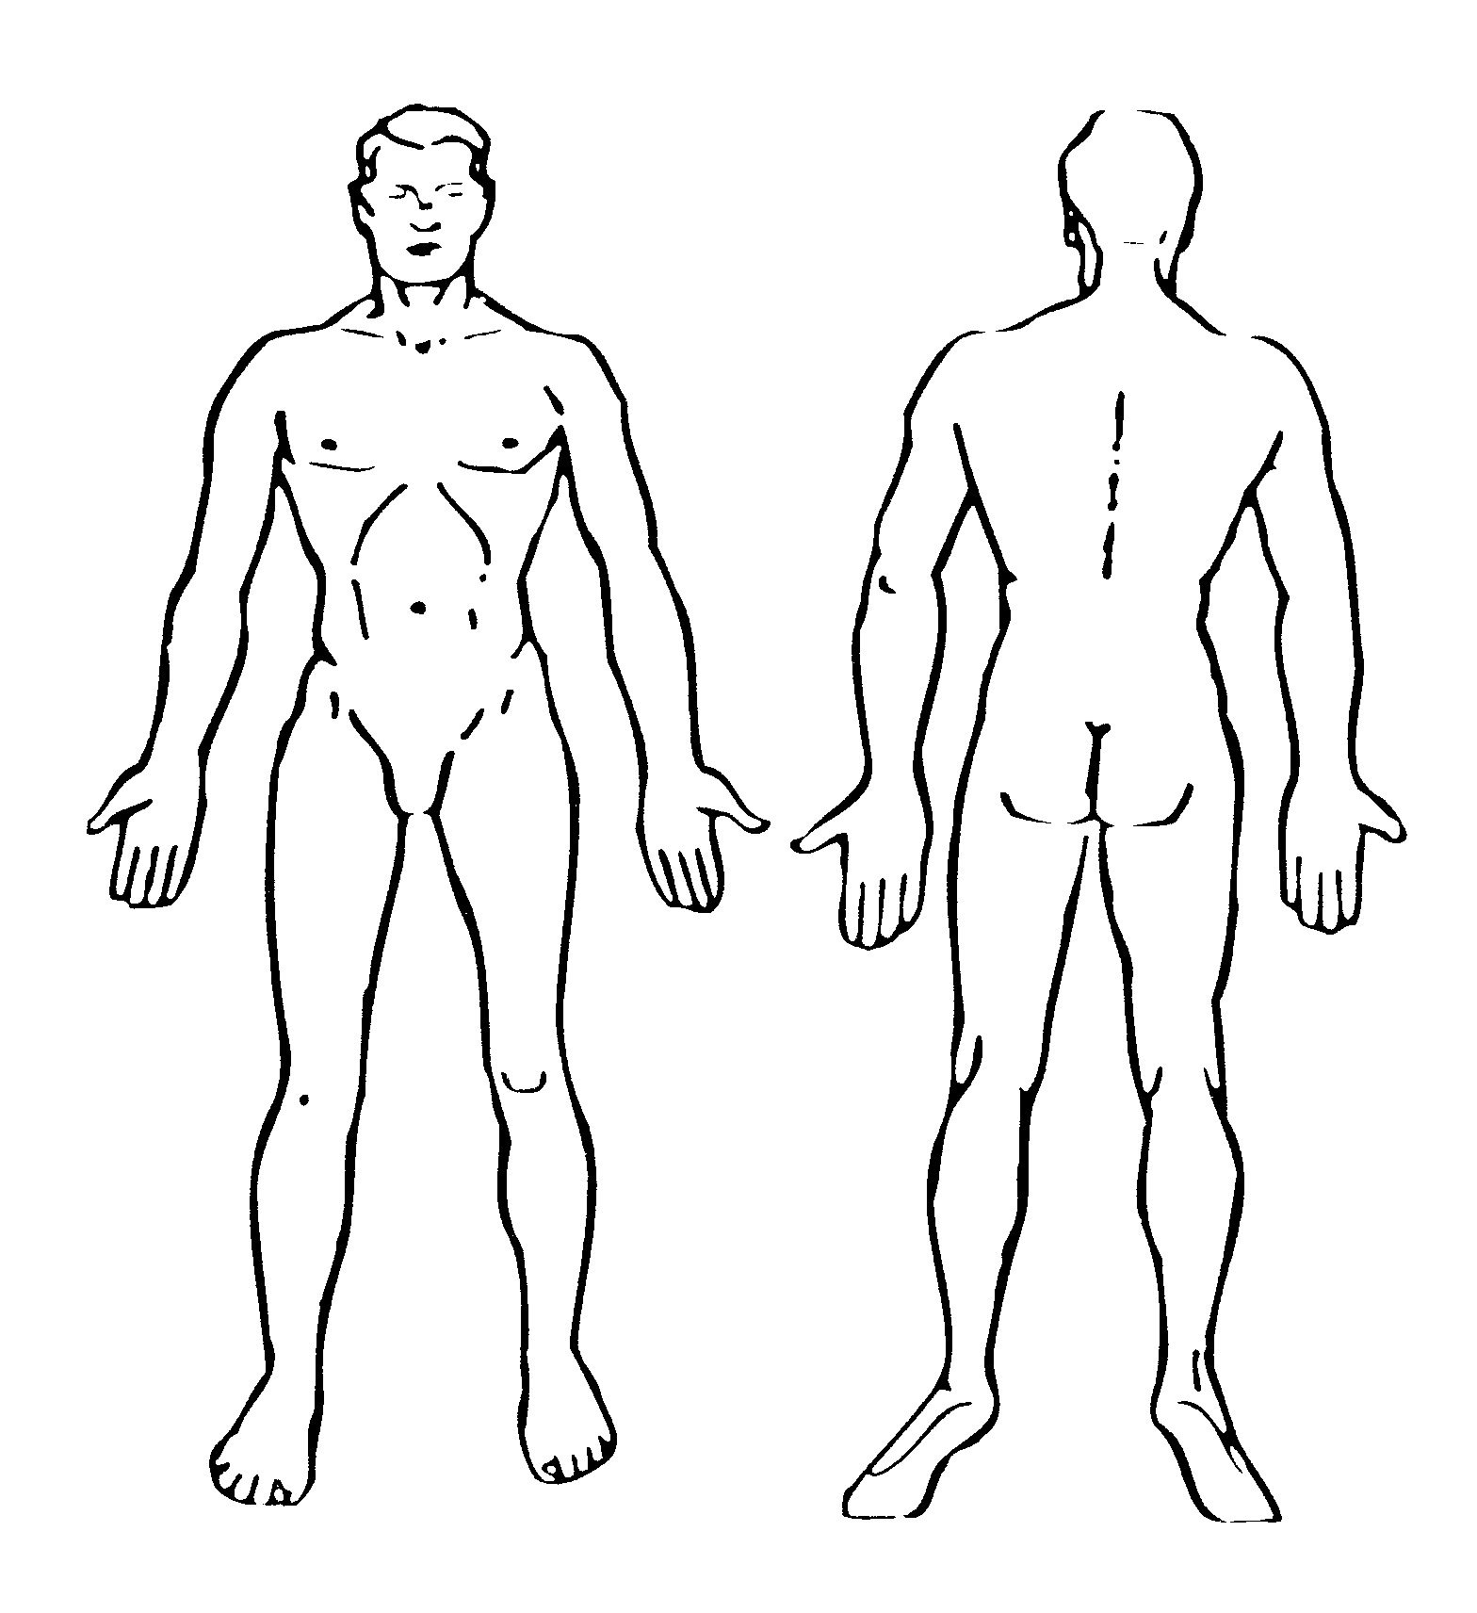

Pick a number from 0-10 to describe your pain:
