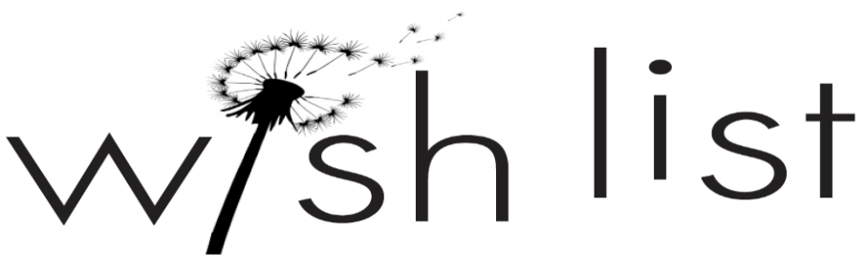

Please Note: All donations items must be new. All cloth/ handmade items will be washed due to infection control standards.

Follow the link below to our Amazon Wish List for products we love:
https://www.amazon.com/hz/wishlist/ls/1FALLRHTENYVY?&sort=default

Infant/Toddler:
Preferred Brands: Fisher Price, Lamaze, Sassy, V-Tech, Baby Einstein, Little Tykes

Crib Toys (crib mirrors, mobiles, projectors, etc)
Infant Rattles, Teethers, and Links
Pop Up Toys
Stacking Toys
Ocean Sound Aquariums
Musical Light-up Toys
Wipe-able Blocks (such as Duplo)
Board Books/ Recordable Books
Activity Gyms and Play Mats
Fisher Price Little People Sets
Wood Puzzles

School age:
Preferred Brands: Fisher Price, V-Tech, Melissa & Doug, Leap Frog, Disney

Plastic/Durable Toys
Plastic cars and trucks/ Match box cars
LEGO sets
Action figures
Barbie (Multicultural)
Baby Dolls (Multicultural)
Animal/ Dinosaur Action Figures
Make Believe Play Sets (Kitchen, Tools, Cash Register, etc)
Fisher Price Medical Kits
I Spy/ Look & Find Books
Books at All levels
Puzzles (25-500+ pieces)

Adolescent Items:
Gift Cards (Amazon, Visa/MasterCard, Starbucks, Target, Walmart, iTunes)
Nail Polish
Teen Coloring Books
Board/Card Games
Advanced LEGO Kits
Beauty Kits
Phone Cases/Pop-Sockets/ Accessories

Electronics:
Xbox One/ PS4 Games (E and T ratings only)
Xbox One and 360 wireless controllers
DVD’s (G, PG, and PG13 only)
Craft and Office Supplies:
Sacred Heart Children’s Hospital uses Crayola brand to assure all craft supplies are non-toxic.
Crayola Brand Crayons, 8 Count Markers, Colored Pencils, and Watercolors
Coloring books
Playdoh and Playdoh cutting/rolling accessories
Model Magic
Sharpie Pens and Gel Pens
Elmer’s Glue
Scissors (Child and Adult sizes)
Plastic Lap Desks
Arts & Crafts Kits (Melissa & Doug, Crayola, Craft Crush)
Drawing Pencils/ Paper

Toiletry Items:
Hair Accessories
Hair Brushes, Combs (wide tooth), and Picks
De-tangler
Shampoo and Conditioner (travel size)
*Miscellaneous Travel Size Toiletry Items.

